EXPERIMENT 4 – CONVOLUTION:

CODE:

# -*- coding: utf-8 -*-

"""

Created on Tue Feb 13 10:48:21 2024

@author: cb.en.u4ece22151

"""

import numpy as np

import matplotlib.pyplot as plt

plt.subplot(4,4,1)

t1=np.arange(-3,3)

x=[-3,-2,-1,1,2,3]

plt.stem(x)

plt.title("x[n]")

plt.ylabel("Amplitude")

plt.xlabel("n")

plt.subplot(4,4,2)

t=np.arange(0,4)

h=[1,-1,1,-1]

plt.stem(t,h)

plt.title("h[n]")

plt.ylabel("Amplitude")

plt.xlabel("n")

def conv(x,h):

N=len(x)

M=len(h)

y=np.zeros(N+M-1)

for n in range(N+M-1):

for k in range(max(0,n-M+1),min(n+1,N)):

y[n]+=x[k]*h[n-k]

plt.subplot(4,4,n+3)

plt.title("Intermediate plot")

plt.ylabel("Amplitude")

plt.xlabel("n")

plt.stem(t,y)

if n==8:

plt.subplot(4,4,11)

plt.title("Final output")

t=np.arange(-3,6)

conv(x,h)

plt.subplot(4,4,12)

con=np.convolve(x,h)

plt.title("Module output")

plt.ylabel("Amplitude")

plt.xlabel("n")

plt.stem(t,con)

plt.tight_layout(pad=0.2)

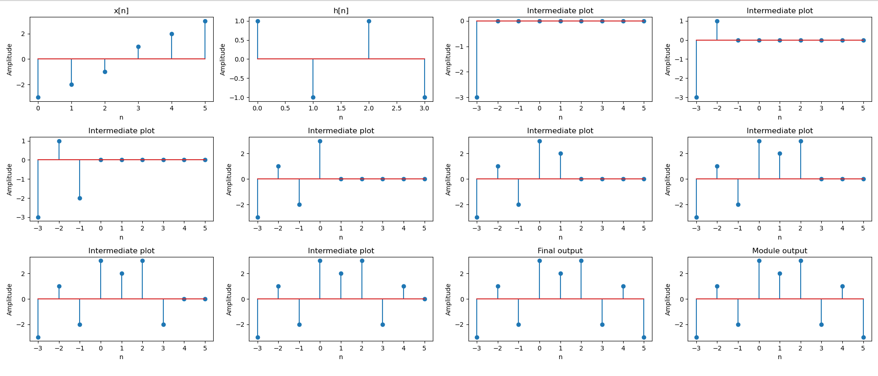OUTPUT: